**Project Documentation**

1. **Introduction**

o **Project Title**: Insight Stream: The News Landscape

o **Team ID:** NM2025TMID47767

o **Team Leader:** AAKASH A (aakashadiyen@gmail.com)

o **Team Members:**

1. ARUN R (rajarun2406@gmail.com)

2. CHANDRU S (s.chandru9566412086@gmail.com)

3. DHANUSH M (dhanushrithilove@gmail.com)

**Roles and Responsibilities:**

**Team Leader – AAKASH A**

Oversees project progress and task allocation.

Coordinates team communication and final integration.

Ensures timely submission and quality of deliverables.

**Team Member – ARUN R**

Frontend development, UI implementation.

**Team Member –CHANDRU S**

Backend integration, API management.

**Team Member –DHANUSH M**

Quality assurance, testing, and documentation.

**2. Project Overview**

* **Purpose:**

The purpose of Insight Stream is to transform how readers engage with digital news by providing a streamlined, trustworthy, and interactive platform that addresses the modern challenges of information overload and fragmented media sources. The project seeks to:

* Simplify news discovery while ensuring credibility and transparency.
* Build user trust through curated, context-driven content.
* Foster long-term engagement via personalized user journeys.
* Drive newsletter subscriptions as the primary conversion metric, supported by additional engagement goals such as AI Copilot sign-ups and social media followership.

Ultimately, Insight Stream is designed to become a go-to hub for navigating the news landscape, bridging the gap between information consumption and meaningful understanding.

* **Key Features**
* Tailored content feeds based on user preferences and behaviours
* **Newsletter subscriptions** as the central conversion goal.
* AI Copilot for guided news exploration and summarization.
* Polls, comment sections, and shareable story insights to deepen user interaction.
* Event tracking for sign-ups, clicks, time-on-page, and funnel drop-offs.
* Data-driven feedback loops to continuously refine campaigns and landing pages.

**3. Architecture**

**• Frontend:** Built with React.js for efficient and responsive single-page experience.

**• Component Structure:** Includes reusable elements like Header, News List, News Card, News Details, and Footer.

**• Backend/API:** Communication to the backend via a dedicated API client, utilizing Rapid API for access to external news feeds and other functionalities.

**• State Management:** Global state managed with Context API for preferences and bookmarks local state with React’s use State for inputs and pagination.

**4.Setup Instructions:**

* **Prerequisites:**

• Node.js and npm installed (Download: nodejs.org)

• React.js installed.

* **Steps:**

• Clone or download the project repository.

• Navigate to the folder: cd insight-stream-news-app

• Install dependencies: npm install

• Set API Key: Add REACT_APP_NEWS_API_KEY= your_api_key_here to the environment.

• Start the app: npm start.5. Folder Structure

**5.Folder Structure:**

• /components (UI elements),

• /pages (Home, Categories, Bookmarks),

• /utils (API, helpers, constants),

• /assets (images, icons, styles).

• /src/components: UI building blocks (Header, NewsList, NewsCard, NewsDetails, Footer)

• /src/pages: Routing and main UI regions (Home, Categories, Bookmarks).

• /src/utils: API calls, helpers, and constants.

• /assets: Images, icons, styles.

• Central app entry points (App.js, index.js).

• Start the app: npm start.

**6.Testing and Optimization:**

• **Testing Strategy:** Comprehensive UI and functional tests with attention to code

coverage. Key features like search and bookmarks undergo detailed trials

• **Performance:** Optimization for handling large datasets and ensuring smooth user

experience across devices.

• **Limitations:** Certain external APIs may have limited access for free plans; bookmark

performance may need further optimization for extensive use cases.

**7.Future Enhancements:**

• Improved personalization (user news history, recommendations).

• Expansion to more news sources and APIs.

• Advanced filtering and collaborative features (sharing articles and collections).

• This documentation provides a clear structure and actionable details for development, deployment, and ongoing team collaboration for Insight Stream.

**8.Project Overview:**

Insight Stream is a news aggregation platform designed for real-time updates, category

filtering, and personalized experiences. The backend handles API communication, bookmark

state, user data, and integrates external services (such as Rapid API for external news feeds).

**9.Architecture and Setup:**

• The application uses a typical React-based frontend, handled via a client interacting with backend API endpoints.

• State management is primarily through Context API for global states (bookmarks,

theme, search); local UI states use React's useState().

**10.Backend Integration:**

• News data is fetched from external APIs using methods in utils/api.js, allowing dynamic updates and filtered browsing.

• Integration with Rapid API or similar platforms for news sourcing, expanding

functionality without building each data pipe from scratch.

• Security keys (such as REACT_APP_NEWS_API_KEY) are managed in environment

variables for secure API access.

**11.Setup Instructions:**

• Clone or navigate to the main project directory.

• Install dependencies using npm install.

• Set environment variables with API keys.

• Start the backend/API server as specified in project instructions and frontend with npm start.

**12.Component and API Documentation:**

• Reusable components for news view, filtering, bookmarking, and details.

• Backend endpoints for search, categories, bookmarks, and personalized feeds.

• Documented using JS/React standards, with context for state and helpers for API

actions.

• Docker Compose or Node.js setup is also referenced for scalable deployment.

**13.Testing and Maintenance:**

• Backend endpoints covered by tests (unit/integration).

• Continuous optimization for API response and bookmark efficiency as data volume

increases.

• Code coverage and testing strategies are outlined, with recommendations for scalability and security.

**14. Screenshots or Demo:**

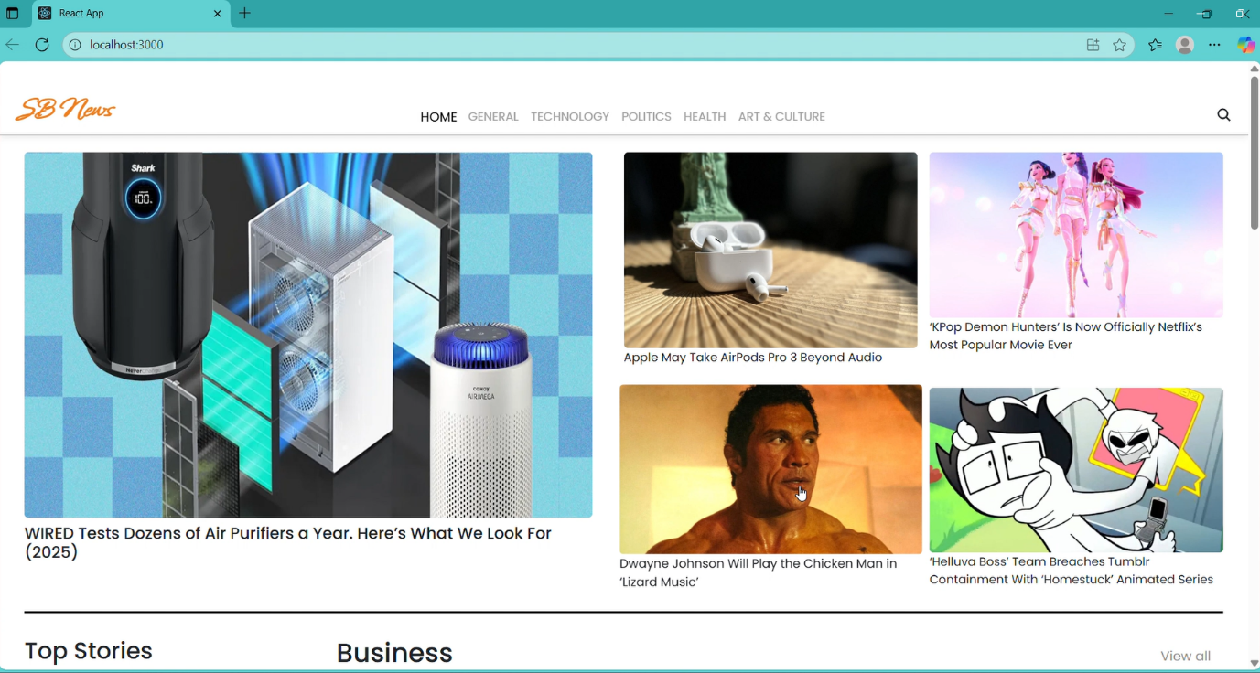

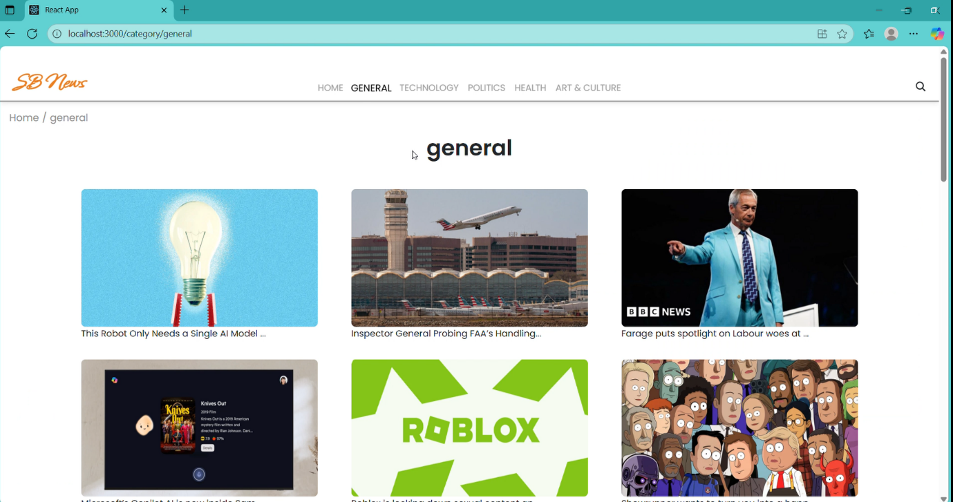

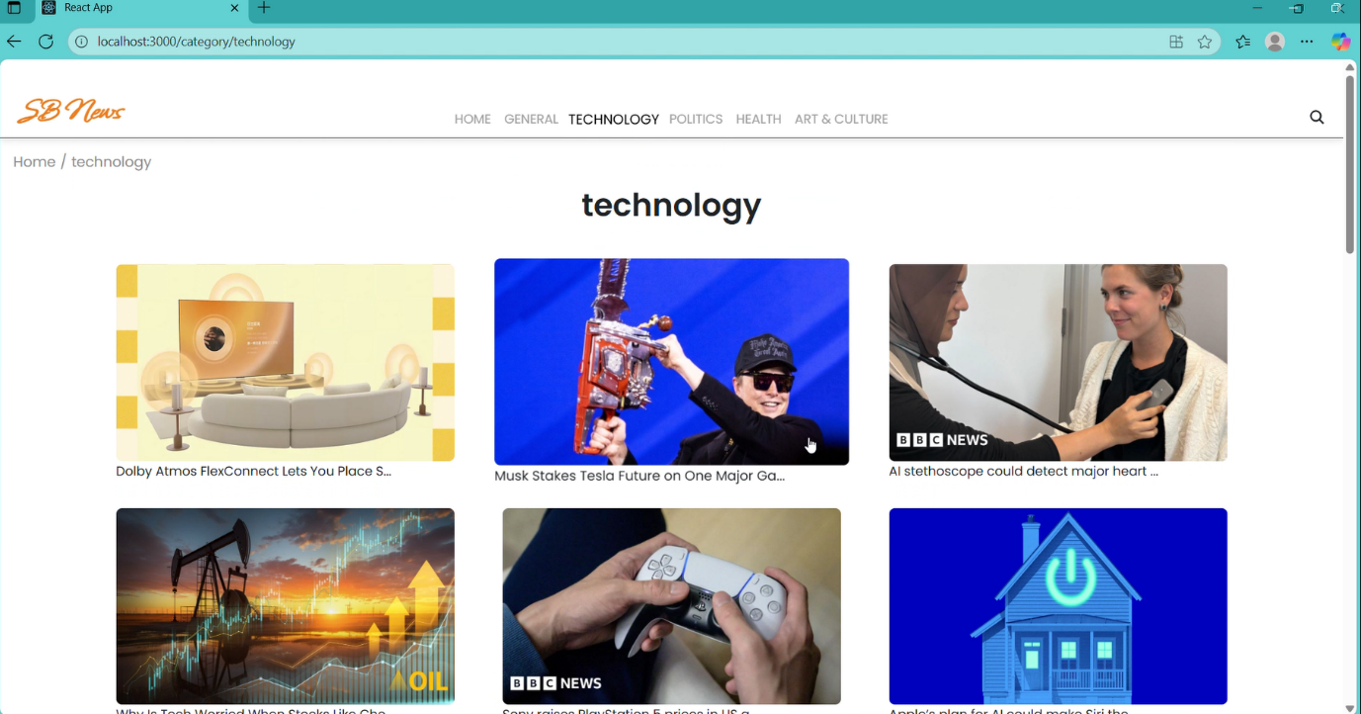

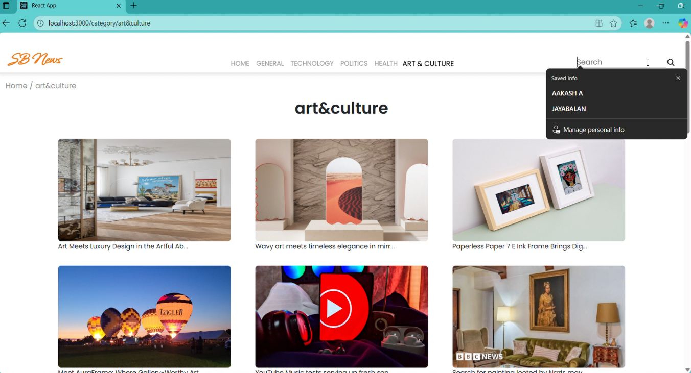

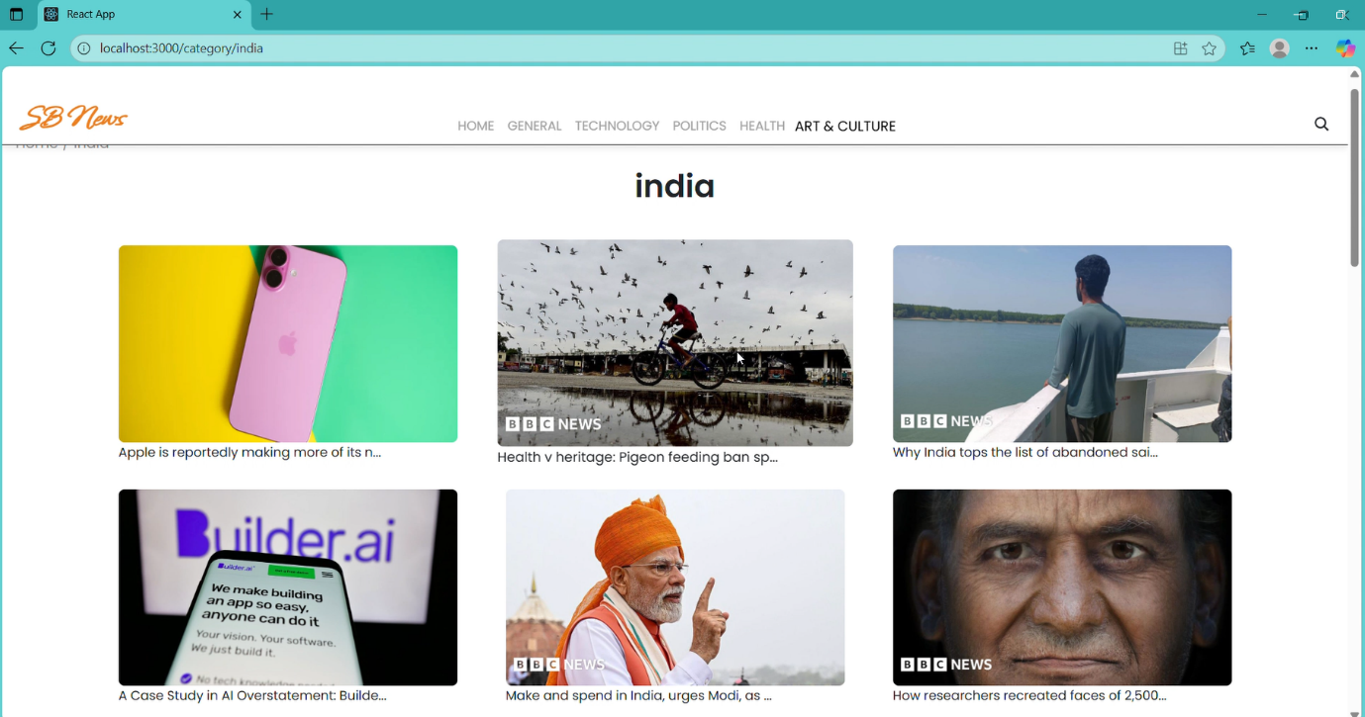

-----THE END-----